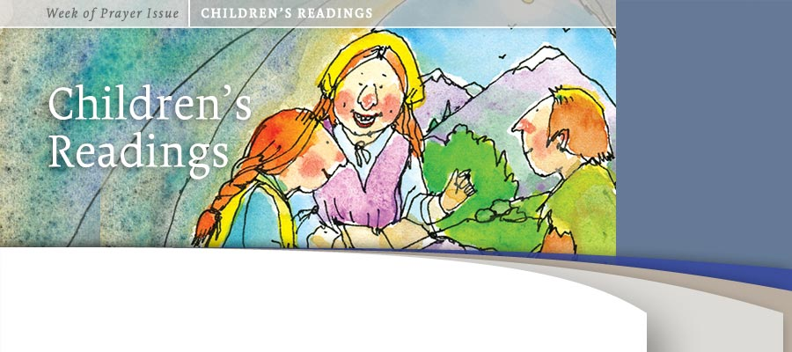
BY ANNE-MAY WOLLAN
First Sabbath: God's Precious Book
Memory Gem “Your word is a lamp to my feet and a light for my path” (Psalm 119:105, Clear Word/Kids).*
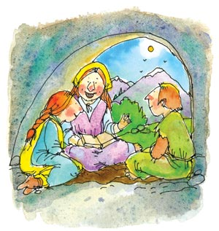
High up in the mountains of northern Italy and France lived a group of people called the Waldenses, who loved God. They loved the Bible and tried to live faithfully according to God’s Word. When the priests and the monks of the Roman Church were the only ones allowed to read and teach the Bible written in the Latin language, the Waldenses had a copy of the Bible, and they translated it into their own language. Many of them even memorized portions of the Bible.

The Roman Church taught people to pray to the virgin Mary and to confess their sins to the priests. But the Waldenses believed what the Bible taught them: that they could pray directly to God.
Whenever the Waldenses met people who showed an interest in God’s Word, they shared what the Bible says about a loving God who had sent His Son Jesus to die on the cross to take the punishment for our sins. The only thing they had to do was believe in Jesus, confess their sins, and ask Him for forgiveness.
When the priest and the monks heard what the Waldenses were teaching, they became very angry and threatened to put them in prison and even kill them if they did not stop. But the Waldenses faithfully continued to study the Bible and share its message. The pope became angry and decided to send his soldiers to punish the Waldenses. When the news that Rome’s soldiers were on their way, the Waldenses fled to the mountains and hid in caves and deep valleys, where the soldiers could not find them. But sometimes the soldiers did find some of them and put them to death. The Waldenses were not afraid to follow God’s Word.
They trusted in Jesus as their good friend who helped them through many difficulties. Jesus also gave them courage to share His message with others. Their lives were changed as they followed what the Bible taught them. They became kinder, more helpful, and braver to witness for God. That meant revival, and they understood how important it was to live their lives according to God’s will.
Share & Do
1. Look up the meaning of the word "revival." Share something you can do when your life is changed by Jesus.
2. Memorize a favorite Bible text and share it with a friend.

The Israelites and God’s Word
The Israelites were a special people chosen by God to be an example to those living around them. God gave the Israelites instructions, through the prophets, not to worship other gods besides Him. He also told them how they were to live and treat each other. They obeyed God most of the time, and as long as they did, everything went well for them. But then they looked at their neighbors’ gods and said, “We want a god that we can see, just like the ones our neighbors have.”
So they started to make themselves gods out of stone and precious metals, and they bowed down and worshipped them. God became angry and sent His prophets to tell the Israelites they would be punished for their unfaithfulness. The Israelites realized that they had done something really wrong, so they destroyed their idols and begged God for His forgiveness. God loved the Israelites and forgave them and blessed them with riches and freedom. The Israelites experienced a revival, which means they changed their ways and worshipped God with all their hearts.
________
* Texts credited to Clear Word/Kids are from The Clear Word for Kids, copyright © 2005 by Review and Herald Publishing Association. All rights reserved.

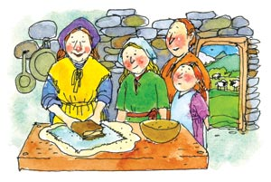
Sunday: God’s Word in My Heart
Memory Gem “I have put Your words in my heart so I won’t sin against You” (Psalm 119:11, Clear Word/Kids).*
Pierre and his wife, Blanche, and their three children, Hubert, Paula, and Gabrielle, lived high up in the mountains in one of the Waldensian valleys. Here among the mountains Pierre built a hut out of stones for his family to live in, and a barn just for the farm animals.
One summer day as Hubert and his two sisters watched their cows and goats up in the hills, they saw a band of Rome’s soldiers coming up the valley. They knew right away that the soldiers were coming for them. They ran as fast as they could down the hill, over the field, and into the small kitchen, where Mother had just finished making bread dough. All three children tried to tell their mother what they had seen.
“The soldiers are on their way up the valley!” Hubert shouted fearfully.
“If they find our Bible, they will take it and burn it, and we will be put in prison,” Paula continued.
“What shall we do, mother?” Gabrielle asked with tears in her eyes.
Blanche thought for a few seconds and quickly said, “Bring me the Bible.”
Hubert hurried and brought it to his mother. Blanche took the bread dough and rolled it out flat, then wrapped the Bible in a kitchen towel, placed it in the dough, and wrapped it around the Bible so it looked like a loaf of bread. She quickly put the bread into the oven to bake.
Minutes later soldiers banged their fists on the door. Blanche opened the door and invited them in.
“We are looking for forbidden Bibles,” the captain of the soldiers snarled. “And we have orders to search your house.”
The soldiers looked everywhere, but found no Bible in the house or in the barn. They even looked in the oven, but saw only a loaf of bread baking.
“Oh, Mother,” said Hubert after the soldiers had left, “I am so happy that they didn’t find our Bible. But just in case they come back one day and take it from us, I want to learn even more of it by heart, because nobody can take away what’s in my heart.”
Share & Do

1. Why do we need to keep God's word in our hearts?
2. What difference can it make in our lives?
3. Make red hearts and paste on them five Bible texts that can help us do what Jesus wants us to do.

A Man After God’s Own Heart
Do you remember how King Saul wanted to kill David? David had done nothing wrong, but was always faithful toward Saul. One day David cut off a piece of Saul’s robe. And another time, David sneaked into Saul’s tent and found him asleep but did not kill him.
“God forbid that I should lay a hand on the Lord’s anointed,” he declared.
So David took Saul’s spear and his water jug and went a safe distance from Saul’s camp. He stood on top of a hill and called out: “Saul, why do you want to kill your servant?”
“Where are your spear and your water jug?” he continued.
“Look, here they are,” he shouted. “I could have killed you while you were sleeping, but how can I do such an evil thing toward God’s chosen king?”
David was a man who kept God’s word in his heart.
________
* Texts credited to Clear Word/Kids are from The Clear Word for Kids, copyright © 2005 by Review and Herald Publishing Association. All rights reserved.

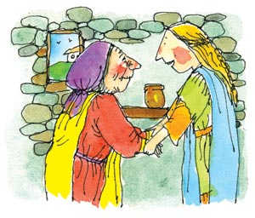
Monday: A Changed Heart!
Memory Gem “The seeds that fell in good soil stand for those who hear the message and retain it in a good and obedient heart, and they persist until they bear fruit” (Luke 8: 15, TEV).*
Twelve-year-old Paula was known for her kindness and love for Jesus. One day her mother asked her to bring a jar of preserved fruit to Louisa, a poor old woman in the village.
Louisa answered Paula’s knock. As Paula entered Louisa’s home, a beautiful black cat followed her in.
“Ah, here comes Cordero!” Louisa explained, “He’s my only friend.”
“I am your friend too,” Paula said. “And there’s another friend who has sent you this gift!” She placed the preserved fruit in the hands of the old woman.
“Is this for me?” Louisa asked. “How can I thank you? No one has ever brought me anything; no one even takes time to speak to me.”
Paula understood how lonely Louisa had been, so she spent some time visiting with her.
It was getting late, and Paula had to leave. Louisa took her hands gently and said, “How can I ever thank you for coming to visit a poor old woman like me whom nobody loves? Do come and see me again soon.”
“Oh, Louisa,” exclaimed Paula, “There is One who loves you. Do you know Him?”
Louisa shook her head sadly. “No, nobody loves me.”
“Jesus loves you, Louisa!” exclaimed Paula excitedly.
“Jesus? Tell me about Him; I have heard that name—who is He?”
And Paula told Louisa about the Lord Jesus, who died on the cross, rose again, and now is in heaven waiting for Louisa to give Him her heart because He loves her.
“He wishes to be your friend,” said Paula. “Just ask Him and give Him your heart.”
That afternoon Louisa prayed and gave her heart to Jesus.
The Fertile Soil
Once when Jesus was teaching, He told His listeners a parable about a farmer who went out to sow seeds in his field. As he scattered the seeds, some of them fell on the road, and the birds quickly came and ate them up.
Some of the seeds also fell among the rocks, where there was very little soil. These seeds quickly sprouted and grew because the soil wasn’t deep. When the sun came up, the plants dried up and died.
Share & Do

1. How can we bear lots of good fruit in our lives? at school? in the community?
2. Make two or three get-well cards and decorate them. Then write a message in each and give them to people in need of encouragement.

Some seeds fell among thorns and thistles, and the weeds grew so quickly that they overpowered the plants. But most of the seeds that the farmers scattered fell on good soil, and the plants bore lots of grain.
When the disciples asked Jesus what the meaning of the story was, He explained that the farmer is out sowing God’s Word. Some people are like the seeds that fall on the road: as soon as they hear God’s Word, Satan comes and takes the seed or truth away.
Some people are like seeds that fall among rocks. As soon as they hear God’s Word, they accept it with their heads but not with their hearts. When problems come along, they give up and leave God.
Others are like the seeds sown among the thorns and the thistles. They hear God’s Word, but the love of money and all the things they want to do get in the way of their desire to follow God’s word.
But some people are like the seeds sown in good soil. They hear God’s Word, accept it, and live their lives according to it. They bear fruits of kindness, helpfulness, and love to people around them. Many learn to love and follow God’s Word, because only God’s Word can change us.
* Bible texts credited to TEV are from the Good News Bible—Old Testament: Copyright © American Bible Society 1976, 1992; New Testament: Copyright © American Bible Society 1966, 1971, 1976, 1992.
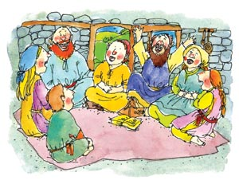
Tuesday: God’s Word in Our Hearts
Memory Gem “Don’t forget to read what Moses wrote. Do it in the morning and at night, so you won’t forget what I said. I will bless you and give you success” (Joshua 1: 8, Clear Word/Kids).*
Autumn had come, the harvest was over, and the hay for the animals and grain and vegetables were all stored away for the winter. Paula and Gabrielle loved this time of year. It was perfect for indoor activities, such as carding wool, weaving, and knitting. But most of all they loved it, because the neighbors would take turns hosting everyone at their individual huts for worship. Gabrielle loved the singing at these worships, especially when a guest came to the valley and would teach them new songs. Paula loved to listen to her uncle read and teach from the Bible. Sometimes the children would have a chance to recite Bible chapters they had learned. Paula already knew most of the book of Matthew by heart, and she had started to memorize the book of Luke as well. Hubert, who had been away at the School of the Barbas (ministers), knew most of the New Testament by heart. He was studying to become a traveling missionary and by the end of his schooling would learn most of the Bible by heart, as well as copy it by hand. The Bible was important to Pierre’s family, for a time could come when they would not have one. Therefore, it was important for them to have it stored in their hearts.
Share & Do
1. Why is it important to study God's Word?
2. Try to memorize today's memory gem and five other Bible verses. Then share them with your Sabbath school teacher and friends.
3. If you memorized one verse from the book of Matthew every day, how many chapters would you know by the end of the year?

Stones as a Reminder
The Israelites had been walking in the desert for 40 years. After Moses died, God appointed Joshua as their new leader. God asked Joshua to remember every day and night to read what Moses had written.
Then He told him: “Today I will show all the Israelites that I am with you just as I was with Moses.”
Finally the day came when the Israelites could cross the river Jordan and enter into the land that God had promised them. God had told Joshua how the crossing should be done, so now Joshua stood on the banks of the river and commanded the priests, who were carrying the ark, to be the first to walk into the river. As soon as the priests’ feet touched the water, the flow upstream stopped. The flow downstream also disappeared. The priests were told to stop in the middle of the river, on dry ground, and stand there until all the Israelites had crossed over. When everyone had crossed over safely, Joshua commanded one elder from each of the tribes of Israel to go into the riverbed where the priests were standing and collect one rock and bring them to him. When all the rocks had been delivered to Joshua, he told the priests to come out of the riverbed. As soon as the priests were safe up on the riverbank, the waters of Jordan returned.
That night when the Israelites camped for the first time in their promised land at a place called Gilgal, they gathered for worship. Joshua took the 12 stones from the Jordan and piled them up. Joshua did this so that every time the Israelites passed by these stones they would remember that God is powerful and worthy of their respect and honor, and that His Word should always be in their hearts.
__________
* Texts credited to Clear Word/Kids are from The Clear Word for Kids, copyright © 2005 by Review and Herald Publishing Association. All rights reserved.

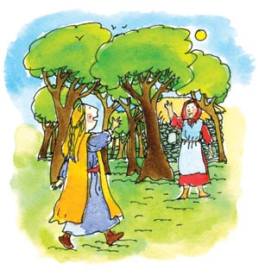
Wednesday: Ruth’s Special Friend
Memory Gem “I will talk about your laws before rulers with no shame whatsoever. I will rejoice in your commandments because I love them” (Psalm 119:46, 47, CEB).*
In the valley where Pierre and his family lived, there was a hut completely hidden among the trees. Eleven-year-old Ruth and her family lived there. When Ruth was just a little girl, she had fallen into the open fireplace and burned her face badly, and now she was very scarred. The children in the village were not nice to Ruth, and they used to tease her and call her “catface.”
Laura liked Ruth, so she decided she would be her friend. When all her chores were done, Laura would run down to the hut in the forest and visit with Ruth. The little girl was very shy, and also scared that Laura might tease her. But as the weeks passed by, Ruth started to trust Laura. One day she asked her, “Why do you come here?”
“I want to be your friend!” Laura answered.
“No one wants to be friends with me,” Ruth said sadly. “I am too ugly to have friends.”
“Who told you that?” Laura asked.
“The children in the village,” she answered.
“Well, I want to be your friend,” Laura answered, “and I know of someone else who also wants to be your friend.”
Ruth’s eyes lit up, and she exclaimed, “I have never had friends before, and now I have two. Who is my other friend?”
“Jesus,” Laura answered. “Jesus is also your friend.”
Ruth bowed her head and with sorrow in her voice said, “He is not going to be a friend to someone like me.”
“Oh, Ruth, He loves you just the way you are. To Him you are beautiful, and He is your friend! You can talk to Him about anything, and He can take away the hurt and sorrow that you feel because of your scars.”
“I want to be His friend as well,” Ruth said. “Help me, Laura; won’t you help me tell Him that I want to be His friend as well?”
Together the two girls prayed, and Ruth accepted Jesus as her friend. Most of all, she thanked Him for loving her as she was.
The Slave Girl’s Testimony
Do you remember the Bible story of the little Jewish maid who was captured by the Syrian king’s soldiers? She was captured and sold to be the servant girl for the wife of Captain Naaman.
When the little Jewish maid learned that her master, Captain Naaman, had leprosy, she went to Naaman’s wife. “I wish that my master could come before the prophet who lives in Samaria. He would cure him of leprosy,” she said.
Share & Do

1. How can you share Jesus with your friends at school and in your community?
2. Make a bookmark and write your favorite Bible text on it. Give it to a friend at school who doesn't know Jesus.

Immediately Naaman’s wife told him what the Jewish maid said, and it brought hope to his heart.
When Naaman finally arrived at Prophet Elisha’s house, Elisha sent his messenger out and said to Naaman:
“Go and wash seven times in the Jordan River. Then your skin will become clean.”
Naaman became really angry and left.
“I thought for sure that he’d come out and call on the name of the Lord his God and cure the leprosy,” he said. “I could just as well have washed myself in the rivers in Damascus.”
But Naaman’s servants said to him, “If the prophet had told you to do something difficult, wouldn’t you have done it? All he said to you was ‘Wash and become clean.’ ”
So Naaman went down to the river Jordan and washed himself seven times, and when he came out of the water the seventh time, his skin was clean.
He hurried back to Elisha and said, “Now I know for sure that there’s no God anywhere on earth except in Israel.”
Though Laura and the little Jewish maid were just children, they were willing to witness for God in heaven. They shared Jesus with others, and the results were amazing.
__________
* Bible texts credited to CEB are from the Common English Bible, copyright © 2011 by the Common English Bible Committee. All rights reserved.

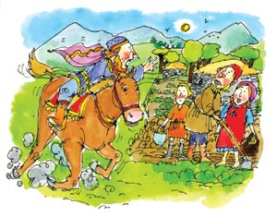
Thursday: A Secret Friend
Memory Gem “So we have no choice but to preach to the Gentiles so that they can be saved. This is what the Lord has told us to do” (Acts 13:47, Clear Word/Kids).*
Pascal lived in the plains below the Waldensian valleys. He was a rich man who believed in the Roman Church. After Pascal met Pierre, who taught him from the Bible, he began protecting the Waldenses. One day Pascal heard that Rome’s soldiers were marching toward the Waldensian valleys, and he knew that Pierre’s family and the other Waldenses were in danger. He took his fastest horse and rode up into the valley to warn Pierre and the others of the danger. On his way up the valley he stopped at every little hut and shouted, “The soldiers are coming!”
Finally he came to the top of the valley, where Pierre and his family lived.
“The soldiers are coming to kill all the Waldenses!” Pascal shouted urgently. “Pack up today and flee to the mountains in France.”
An hour later Pierre, Blanche, Hubert, Paula, and Gabrielle started their long and dangerous walk across the mountains to safety.
A Persecutor Becoming a Follower
Saul, like the soldiers in the Waldensian story, persecuted the followers of Jesus. Saul believed with all his heart that this traveling preacher, Jesus from Nazareth, who had recently been crucified, was a false prophet and his followers had to be put to death. He had already gotten many Christians killed, and now he was traveling to Damascus with a letter from the high priest giving him permission to take all Christian men, women, and children as prisoners to Jerusalem.

Share & Do

1. Why is God's Word able to change people?
2. Make a list of things you stopped doing after you made Jesus your friend.

He was getting close to Damascus when suddenly a bright light from heaven flashed all around him. Saul fell to the ground, hiding his face. Then he heard a voice coming down from heaven saying, “Saul, why do you persecute Me?”
“Who are You, Lord?” Saul asked fearfully.
“I am Jesus, the one you are persecuting.” The voice replied. “Now get up and go into Damascus, and there you will be told what to do.”
The soldiers traveling with him were completely speechless. They had heard the sound but had not seen anyone. Saul slowly stood up and opened his eyes to see, but to his horror, he could not see anything. He was blind!
The soldiers led him by the hand into Damascus. For three days Saul was blind. But God told Ananias to go and heal Saul, saying, “Go! I have chosen this man, and he is going to be a missionary for Me to the Gentiles.”
Ananias went to the house where Saul was staying. He put his hands on Saul, and his sight returned. Saul was changed when he met Jesus. He became Paul, a follower of Jesus who traveled all over the Mediterranean preaching and teaching about Jesus. He was no longer a persecutor.
By meeting Jesus, we are changed. Pascal became a protector of God’s people, and Saul became a powerful preacher.
* Texts credited to Clear Word/Kids are from The Clear Word for Kids, copyright © 2005 by Review and Herald Publishing Association. All rights reserved.

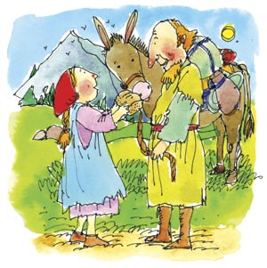
Friday: A Temptation Almost Too Big
Memory Gem “Man can’t live on bread alone, but needs the Word of God” (Matthew 4: 4, Clear Word/Kids).*
Many of the other Waldensians from the valley joined Pierre and his family as they made their way up the mountain. For supper that first evening Blanche gave everyone just one small piece of bread. They had many more days of traveling, and the food they brought along had to last for the entire journey.
Three days of walking went by, and only one mountain pass had been crossed. Gabrielle was tired and hungry, and all she could think about was food and sleep. That evening she cried herself to sleep, and when morning came, she didn’t want to get up. Paula was worried about her little sister and promised her she would give her some of her bread if she would get up and get ready. At once Gabrielle got up and was ready for the day’s walk.
Later that day as they continued their climb, Gabrielle saw something fall off the back of their neighbor’s mule.
It was half a loaf of bread!
I’ll hide it under my coat and not tell anyone. Then I can eat it when I get hungry, thought Gabrielle.
They will be really hungry when they have nothing to eat, she thought again. This is not right. It is stealing.
The Bible says it is wrong to steal, her conscience kept telling her.
She could not do it—it was wrong. So she took the bread out from her coat and ran up to the family and told them it had fallen off their mule. That evening Gabrielle was happy for the small piece of bread that was given to her.
Jesus and the Tempter
Remember Jesus was also tempted in the wilderness where He spent 40 days praying and not having anything to eat. After 40 days of fasting and Jesus was really hungry, Satan appeared as an angel before Him.
“If You are the Son of God, You could turn these stones into bread.”
Share & Do

1. How can God's Word help us resist temptation? List four or five ways.
2. List two Bible texts that can help us resist Satan's temptations.

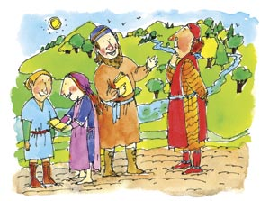
Jesus knew it was Satan who was tempting Him, so He answered:
“Man can’t live on bread alone, but needs the Word of God.”
Satan was not about to give up, so he took Jesus with him to Jerusalem, to the highest point on the Temple, and said to Him:
“Show me how much faith you have in God by jumping off this wall. The Bible says that God will send angels to take care of those who love Him.”
But Jesus knew that Satan was mixing truth with untruth and said:
“God does not want us to show how much we trust Him by doing something foolish.”
Satan did not want to give up, so he took Jesus to a very high mountain and showed him a beautiful view of the world and said to Him: “You don’t have to die to save the world. I’ll give You all this if You’ll just bow down and worship me.”
“Get away from Me, Satan. For it is written, worship the Lord your God and serve Him only. God is the one who owns this world,” said Jesus.
Immediately Satan left. Jesus was so weak from going without food and water for 40 days that He was close to dying, but God sent His angels to help Him and give Him strength.
_______
* Texts credited to Clear Word/Kids are from The Clear Word for Kids, copyright © 2005 by Review and Herald Publishing Association. All rights reserved.
Second Sabbath: Going on God’s Mission
Memory Gem “Go and share the good news with everyone. . . . Teach them everything I’ve taught you. I’ll always be with you, right up to the end of the world!” (Matthew 28:19, 20, Clear Word/Kids).*
Weeks had passed since the Waldenses had left their homes in the Italian valley. They had crossed several mountain passes, and now, as they came across the ridge of a high mountain, they stopped and saw a beautiful valley. They had arrived in France, and could settle down and be safe. This lovely place also had tall trees, beautiful flowers, and a rushing river running down from the mountains.
Each family found a new place to make their homes. Pierre and his family found a small side valley where they built a small hut that could shelter them from winter storms. Paula, Gabrielle, and their mother got busy gathering supplies they would need for the winter. They found berries, nuts, and mushrooms in the forest, and collected firewood. Everyone was busy, but they still found time to make friends with many French people who lived near them. It did not take long before Pierre had invited them to join them for worship. He shared the good news of Jesus every day, and soon they came to enjoy the good news that Pierre shared from the Bible.
Everywhere the Waldenses went they shared God’s Word with people around them. This was how God’s Word spread throughout Italy and France during the time the Bible was thought to be the property of the Roman Church. The Waldenses began a revival, and many people turned their hearts to God.

Share & Do
1. How can you be a missionary today to witness for Jesus?
2. Make a plan with your parents for Sabbath school teacher for sharing Jesus with others. Remember to pray for each of those individuals.

The Revival in Ephesus
Remember how Saul, who later became Paul, became a changed man when he met Jesus? The revival that Saul experienced in his life made him a powerful missionary who brought many people to Jesus.
Paul caused a revival everywhere he went, especially in a city called Ephesus. Some believed what he was preaching, and some did not. The nonbelievers started to spread rumors about the Christians, so Paul moved his meetings from the synagogue to a school and continued to preach for two years, until almost everyone in Ephesus and the surrounding area had heard about Jesus.
God performed some extraordinary miracles through Paul, and many grew to give the name of Jesus respect.
Some of the believers, who had been playing with magic and trying to talk to the dead, decided to stop doing that. Soon they brought their books about magic to the town square and burned them all on a huge bonfire.
Because of Paul’s preaching a revival began, lives were changed, and many people chose to live according to the teachings of the Bible and became followers of Jesus.
________
* Texts credited to Clear Word/Kids are from The Clear Word for Kids, copyright © 2005 by Review and Herald Publishing Association. All rights reserved.
___________
ANNE-MAY WOLLAN served in the Trans-European Division for many years. She now lives in the United States and is devoted to empowering church leaders and volunteers who have a heart for ministry to children. All illustrations by Terry Crews. This article was published September 27, 2012.

