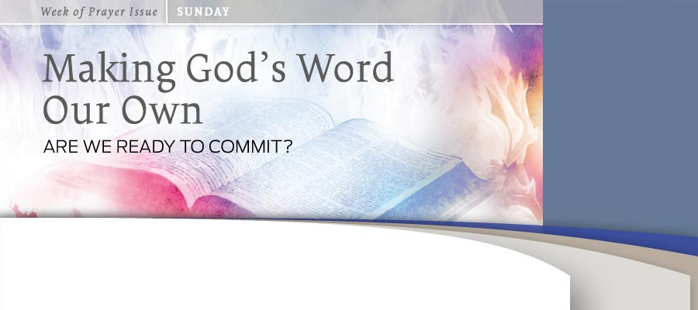
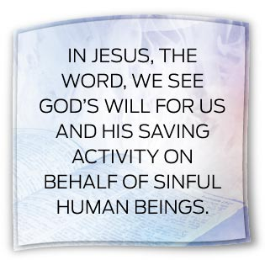
BY áNGEL MANUEL RODRíGUEZ
Life is not self-sustaining. Living organisms depend on elements from outside themselves to remain alive. Water, food, oxygen—to mention just a few—are indispensable for life to exist.
From a biblical perspective, only God can sustain and preserve life in an environment that is in a state of decay and constitutes a constant threat to a meaningful human existence. Life is particularly sustained through the Word of God. This is especially true in our spiritual lives, which need constant power from outside ourselves to remain vibrant.
God and the Word
The psalmist wrote, “By the word of the Lord the heavens were made” (Ps. 33:6). Creation in general and life in particular came into existence through the power of the divine Word. Human existence itself is predicated, not on food alone, “but on every word that comes from the mouth of the Lord” (Deut. 8:3).
The connection between life and the divine Word is deep, unfathomable, and constant. The Word that created is the same Word that constantly sustains creation. The power of God is revealed to us in His Word, His speaking to us.
Through His Word God speaks to us in our particular situations and reveals to His people His plan and His will for them. His Word always aims at our well-being, because it is “good” (Isa. 39:8). At Sinai the Israelites heard the Word of the Lord speaking to them and giving them “regulations and laws that are just and right, and decrees and commands that are good” (Neh. 9:13). The Word often takes the form of a promise on which we can always count and that anticipates the full realization of God’s saving plans for us (Ps. 105:42-45).
Solomon spoke to the people about the power of the divine Word: “Praise be to the Lord, who has given rest to his people Israel just as he promised. Not one word has failed of all the good promises he gave through his servant Moses” (1 Kings 8:56). God’s Word is reliable and dependable because He fulfills what He promises: “For the word of the Lord is right and true; he is faithful in all he does” (Ps. 33:4). God acts in accordance with what He says; He is a God of honor.
Jesus and the Word
The Word of God is much more than an audible utterance coming from the divine mouth. It is visible: “In the beginning was the Word, and the Word was with God, and the Word was God. He was with God in the beginning. Through him all things were made” (John 1:1-3). This is the same reliable, trustworthy, and powerful Word of God that addressed His people in the Old Testament. But in the New Testament something glorious and unexpected happened: “The Word became flesh and made his dwelling among us. We have seen his glory, the glory of the one and only Son, who came from the Father, full of grace and truth” (verse 14).
In Jesus, the Word, we see God’s will for us and His saving activity on behalf of sinful human beings. The audibility of His Word is efficacious because in Jesus God speaks to us (see John 14:10). But as the incarnated Word of God Jesus is the Word of truth (see 2 Cor. 6:7), the Word of reconciliation (see 2 Cor. 5:19) and salvation (see Acts 13:26); He is the Word of the cross (see 1 Cor. 1:18). He is the truth, as well as the one who in the mystery of the Incarnation united God and humankind, and who on the cross exhibited the saving power of the Word of God.
God can indeed accomplish what He utters. When God says something, it happens. It may not take place as quickly as we would like, but it will happen.
God’s Word performs that which it announces or expresses. The psalmist wrote that God “sent out his word and healed them [His people]; he rescued them from the grave” (Ps. 107:20). Referring to the Word that goes out of His mouth, the Lord says, “It will not return to me empty, but will accomplish what I desire and achieve the purpose for which I sent it” (Isa. 55:11). When the Lord speaks, things happen!
When the storm on the Sea of Galilee threatened the safety of His disciples, Jesus stood up, “rebuked the wind and said to the waves, ‘Quiet! Be still!’ Then the wind died down and it was completely calm” (Mark 4:39). He commanded demons to leave their victims, and they came out of them (see Mark 1:25). He healed people by saying the Word (see Matt. 8:8)! But above all, His word proclaiming forgiveness brought forgiveness to the sinner (Matt. 9:1-7). It delivered what it announced!
God’s Word and Me
We are the addressed of the Word of God. He speaks to us as Creator and Redeemer because we have to know His plan and His will for us. We have to come out of our existential darkness into the light of a meaningful life.
God’s Word is the source and fountain of eternal life (see John 5:24; 6:63). We have to come to know that Word because, as demonstrated in the life of Jesus, God’s Word touches every aspect of our lives. Listening to the Word is a matter of life or death. Consequently, God is eager to be heard by us: “I revealed myself to those who did not ask for me; I was found by those who did not seek me. To a nation that did not call on my name, I said, ‘Here am I, here am I’” (Isa. 65:1).
Questions for
Reflection and Sharing

1. God speaks to us in creation. In what works of nature do you especially recognize God's creative and sustainng power?
2. The power of God's Word is also demonstrated in the life and earthly ministry of Jesus. In which stories from Jesus' life do you see the power of God's Word revealed.
3. God's power is also displayed in His Word of redemption revealed in each of our lives. How have you felt the power of God's Word in your own life?

Therefore we are challenged to listen to the divine Word speaking to us in Scripture (see Isa. 66:4). This is a dynamic hearing that is accompanied by doing what the Word says. Jesus said, “Therefore everyone who hears these words of mine and puts them into practice is like a wise man who built his house on the rock” (Matt. 7:24; cf. 2 Chron. 34:21).
Our obedience to the Word reveals that we have indeed heard it speaking to us and that we have appropriated it. But it is also important to read the Word under the guidance of the Spirit, for it is only the incarnated Word of God who can transform us (see 2 Cor. 3:15-18). We should search it because it testifies about the only One who can grant us eternal life (see John 5:39). In the process of appropriating the Word we have to meditate on it, to allow our thoughts to dwell on the content of the Word and on its significance for us as individuals. We can meditate in the Word as it expresses itself in commands (see Ps. 119:48), testimonies (verse 99), and promises (verse 148).
Appropriating the Word requires us to invest time with it. This is unnatural to the human heart and requires breaking away from spiritual inertia. Prayer becomes indispensable because through it we can ask the Lord to place in our hearts the desire and the willingness to listen to His Word.
We should act out our prayer by opening the Word every day. The more we read it, the better we will come to understand its message. We mustn’t quit because we are unable to understand everything we find there. Just read it, allowing its message to penetrate our minds. In that process God’s thoughts will bathe our minds, and we will slowly be transformed by the power of the Spirit.
When we listen, read, and meditate on the Word, something glorious happens: Christ, the Word, comes to dwell in our hearts through faith (see Eph. 3:17).
The Word is alive; therefore it can revive us: “For the word of God is alive and active. Sharper than any double-edged sword, . . . it judges the thoughts and attitudes of the heart” (Heb. 4:12). Since it is still alive, it can perform in our lives what it announces. We can believe in it because the One who speaks to us through the Word is reliable and has the power to bring to reality what He has promised.
Therefore, let’s allow the Word to instruct us every day (see 2 Tim. 3:15). Let it comfort us as we face difficulties, temptations, and suffering (Ps. 119:161, 162). Let the hope found in its pages fill our hearts with joy (see Ps. 56:10, 11;
2 Cor. 1:20).
Let’s allow the Word of the cross to fill our hearts and burn like a fire, in order to sanctify us in service to the Lord and to others (cf. Jer. 23:29).
________
Prior to his retirement in 2011, ángel Manuel Rodríguez served as director of the Biblical Research Institute. He now lives in Texas. This article was published September 27, 2012

