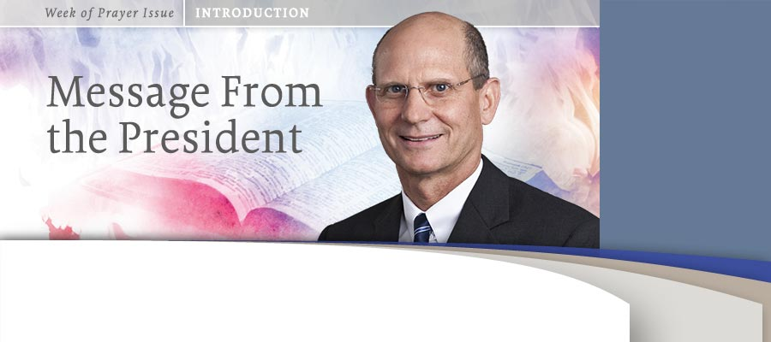
Dear Church Family:
What an exciting and important topic we will be studying together during this Week of Prayer in 2012—“Revival and the Word.”
The theme of revival is found again and again in the Scriptures. God’s hand is constantly restoring and reviving those who were lost, giving life and strength to the weary, and seeking to bring about a revival in the relationship between Himself and His people.
Throughout this week we will focus on several specific ways in which the Word is integral to revival in our own hearts and homes, as well as in the church. Certainly there can be no true revival without the study of God’s Word and by experiencing a deep and continuing fellowship with Jesus Christ.
I invite you to join with your world church family in a special way during this Week of Prayer. As you read and contemplate the main points of each reading, ask the Holy Spirit to reveal how you can appropriate that message in your life that day. Pray that the Lord will send the latter rain of the Holy Spirit to revive each one of us individually and corporately. If you have children in the family, be sure to include them by sharing the special children’s readings together.
God’s Word urges us, “O taste and see that the Lord is good. How happy is the man who trusts in Him! O fear the Lord, all you who belong to Him. For those who fear Him never want for anything” (Ps. 34:8, 9, NLV).*
Jesus is coming soon! May He strengthen and revive each one of us and His remnant church with the latter rain as we seek to proclaim the three angels’ messages and prepare to meet the Lord in the air.
With kind Christian regards and sincerely yours,
Ted N. C. Wilson
President
* Bible texts credited to NLV are from the Holy Bible: New Life Version. Copyright © 1969 by Christian Literature International. P.O. Box 777, Canby, Oregon 97013. Used by permission.

